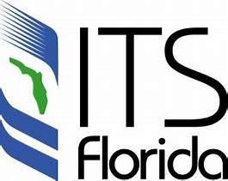

ITS FLORIDA TECHNICAL COMMITTEE
2023 2nd QUARTER MEETING
April 11, 2023

- Website/Forum discussion – itsflorida.org
  - Membership information, Events Calendar, Job Postings, etc…
- FDOT Central Office Discussion
  - TERL Approvals since last meeting are in the Excel attachment to the meeting invite.
Supplier Name | Product Name | Approval Number | Model Number
GovComm, Inc. | GovComm Aluminum Small Equipment Enclosure | 676-044-004 | GC-ENC-241612
Image Sensing Systems (formerly EIS) | Image Sensing System, Wrong Way Alerting Solution | 660-014-006 | AID-WW-700

  - Specifications/Standard Plans updates
    - 633-5 Fiber Optic Cable Locator (and associated Method of Measurement)
  - Connected Vehicle or other Developmental Specifications updates, etc…
- Upcoming Meetings
  - The next meeting will be an in-person meeting at the I3 Conference and will have a teleconference option.
- Open Discussion

NOTE: Please remember that this committee is for the benefit of all ITS Florida member organizations, companies, and individuals. These meetings will be held in a manner that provides knowledge and encourages discussion of industry related topics. Solicitation of products is discouraged, as is, any negative comments regarding a company or their product/services.

